Suring New Zealand – Proposed Constitution

Surfing New Zealand (Surfing NZ) proposes to amend its Constitution in the form set out in the attached papers. This summary does not purport to set out all changes between the current Constitution and the proposed Constitution.
Rule references below are to Rules in the proposed version of the Constitution, unless stated otherwise.

Mandatory changes
A number of the changes are required to comply with the Incorporated Societies Act 2022 (Act). These include:

Member consent (Rules 5.4 and 10.4): A requirement that a person must consent to be a member of Surfing NZ.

Resignation and Termination of Membership (Rule 12): If an individual on death, or if a body corporate on liquidation; by giving notice to Surfing NZ of their resignation; or if their membership is terminated following a dispute resolution process or such other process set out or referred to in the Constitution.

Register of Members (Rule 14): Arrangements for keeping Surfing NZ’s members register up to date and what the register must contain.

Contact Person (Rule 15): The appointment of a Contact Person whom the Registrar of Incorporated Societies can contact when needed.

Ceasing to be a Board Member (Rule 19.15): A person ceases to be a Board Member if their term expires or the person resigns, is removed from office under the Constitution, becomes disqualified from being an officer under the Act or dies.

AGM date (Rule 24.1): Surfing NZ must hold an AGM not more than 6 months after the balance date of Surfing NZ.

Business of AGM (Rule 24.5): That the annual report for the preceding financial year, the auditor’s or reviewer’s report to Members on the annual financial statements and conflicts of interest of Officers must be presented at AGMs.

Written resolutions in lieu of General Meetings (Rule 24.25): These are not permitted.

Finances (Rule 25): That the funds and property of Surfing NZ are controlled, invested and disposed of by the Board, subject to the Constitution and devoted solely to the promotion of the Purposes.

Dispute Resolution (Rule 27): A dispute resolution process must be included in the Constitution that is consistent with the clauses of natural justice. The Rules set out how Surfing NZ might manage disputes and other matters arising that are dealt with under policies or bylaws, while ensuring that it complies with the Act’s requirements. There are also dispute procedures within the Constitution for certain circumstances, for example removing a Board Member. The flow chart in Appendix A helps to determine the correct procedure for handling a certain dispute or other matter.

A description of the officers’ duties under the Act is set out in Rule 20. The conflicts of interest regime set out in the Act, including how ‘interested’ is defined, disclosure requirements and the consequences of being interested, has also been included in Rule 21.
Additional changes
It is proposed that the following additional changes are made to enhance the Constitution from a governance perspective and to ensure it reflects Surfing NZ’s strategic and operational environment:

Board Appointments Panel (Rule 18.2(a)): The Chair or Board Member appointed to the BAP must not have reached the end of their maximum term to ensure there is a current Board Member on the BAP.

Qualification (Rule 19.6): That a person must consent to be a Board Member and must certify that are not disqualified under the Act and the Constitution from being a Board Member.

Suspension of Board Member (Rule 19.10): If a Board Member’s may be disqualified from holding office or any other circumstances arise in relation to them which are or may be of concern to the Board, the remaining Board Members may, by Special Resolution, suspend the Board Member from the Board. Before imposing any suspension, the Board Member must be given notice of the suspension.

Matters not provided for (Rule 20.2): If any disputes arises out of the interpretation of this Constitution or any Regulations, the dispute will be determined by the Board.

Quorum (Rule 24.13):

The quorum includes Members present by casting votes by electronic means (if that method of voting is permitted by the Board).

If a quorum is not obtained for a SGM, which is adjourned, then a quorum is not obtained for a further SGM, the SGM is cancelled.

Common Seal (previous Rule 25): This has been removed as it is no longer required under the Act.

Integrity Code (Rule 26): These Rules do not predetermine that Surfing NZ will adopt the Code of Integrity for Sport and Recreation issued by the Sport Integrity Commission, but provides a framework for consistent application if it does. The Rules set out how the application of the Integrity Code will cascade down the surfing system. They include a requirement of Members to include in their constitutions that if Surfing NZ adopts the Integrity Code their respective members agree to be bound by it.

Alterations of Constitution (Rule 28): The Act permits the Board to give notice of a minor or technical amendment to Members, and give them the right to object to such amendment. If an objection is received, the Board may not make the amendment.

Prohibition on personal benefit (Rule 29): Reflects wording required by IRD.

Liquidation and removal (Rule 30): A Special Resolution of Members may remove Surfing NZ from the Incorporated Societies register and to distribute Surfing NZ’s surplus assets.

Indemnity and insurance (Rule 31): Amendments to reflect the indemnity and insurance regime under the Act.

Transition (Rule 32): The current Board Members continue as Board Members under the new Constitution until their current terms expire.
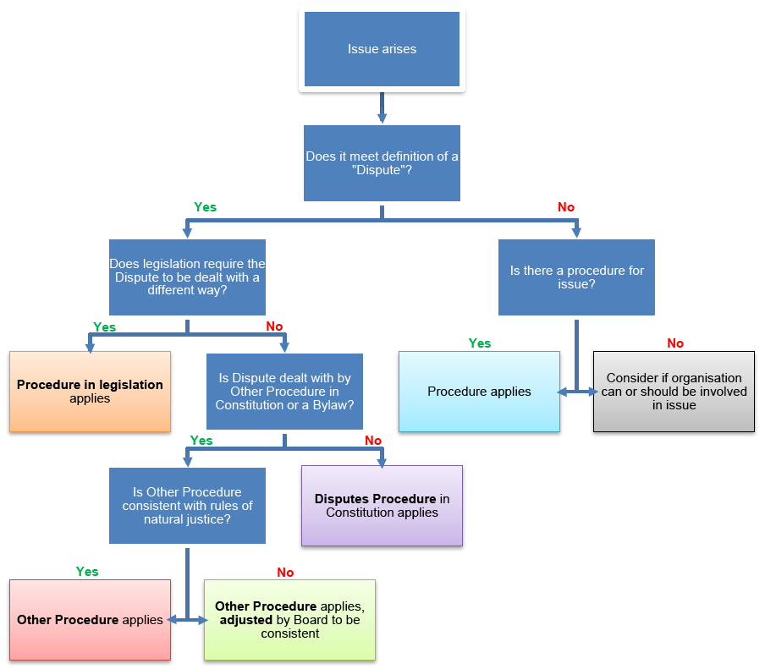
Appendix A – Flow chart for managing disputes

